**Exercise 4: Creating and Configuring a Maven Project**

**Steps:**

1. **Create a New Maven Project:**

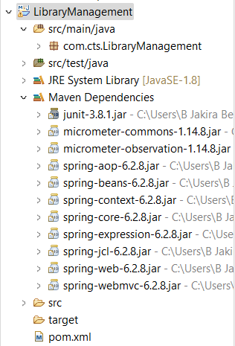

1. **Add Spring Dependencies in pom.xml:**

**pom.xml**

<dependencies>

<dependency>

<groupId>junit</groupId>

<artifactId>junit</artifactId>

<version>3.8.1</version>

<scope>test</scope>

</dependency>

<!-- https://mvnrepository.com/artifact/org.springframework/spring-context -->

<dependency>

<groupId>org.springframework</groupId>

<artifactId>spring-context</artifactId>

<version>6.2.8</version>

</dependency>

<!-- https://mvnrepository.com/artifact/org.springframework/spring-aop -->

<dependency>

<groupId>org.springframework</groupId>

<artifactId>spring-aop</artifactId>

<version>6.2.8</version>

</dependency>

<!-- https://mvnrepository.com/artifact/org.springframework/spring-webmvc -->

<dependency>

<groupId>org.springframework</groupId>

<artifactId>spring-webmvc</artifactId>

<version>6.2.8</version>

</dependency>

</dependencies>

1. **Configure Maven Plugins:**

<build>

<plugins>

<plugin>

<groupId>org.apache.maven.plugins</groupId>

<artifactId>maven-compiler-plugin</artifactId>

<version>3.8.1</version>

<configuration>

<source>1.8</source>

<target>1.8</target>

</configuration>

</plugin>

</plugins>

</build>

